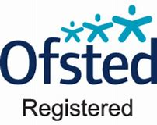

KidsZone

QUALIFIED &

EXPERIENCED STAFF

ALL DBS CHECKED

Fully Inclusive Programme With Focussed Activities For 3-8s and 8-11s

All Dietary Requirements Catered For In Our NUT FREE Environment

EASTER HOLIDAY CLUB

4TH – 14TH APRIL 2022

 *BOOK AND PAY BY 16TH MARCH FOR EARLY RATE*

**MALMESBURY PRIMARY SCHOOL, NEWMINSTER ROAD, MORDEN, SM4 6HJ TEL: 07519 649926**

**OFFICE: office@kidszoneoosc.co.uk TEL: 07817 241463**

**WEBSITE: www.kidszoneoosc.co.uk**

**OFFICE: office.kidszone@gmail.com**

**TEL: 07817 241463**